Open Design Technology Assignment 1

Vruddhi Dempo Section C

Prompt 1

Create an image representing the interface of a mental health app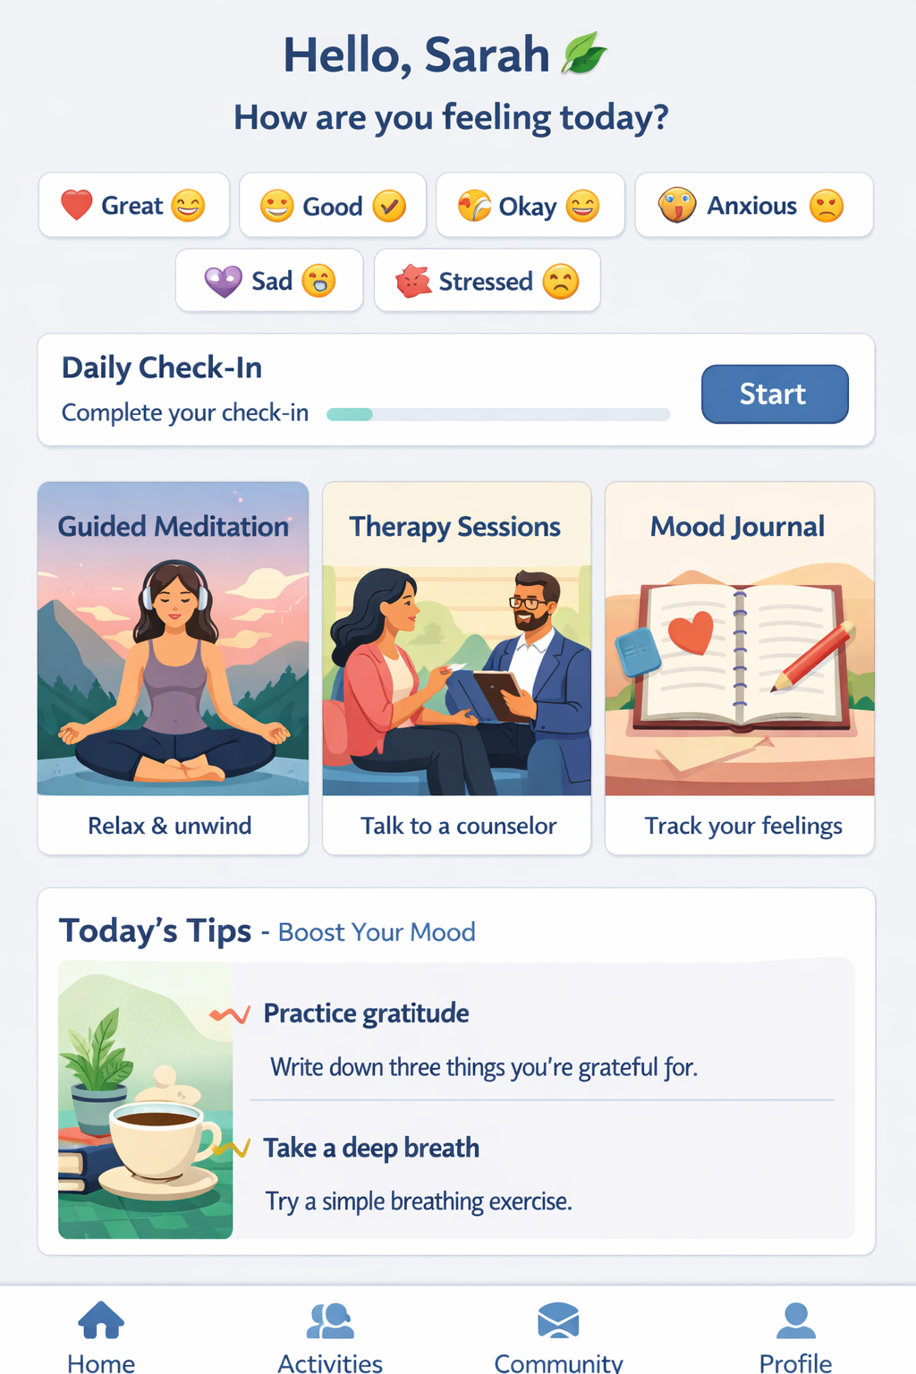

Prompt 2

You are a scuba diver. Create an image showing the interface of features available in your app about mental health and wellbeing called iThink. It is a serene, ocean themed app.

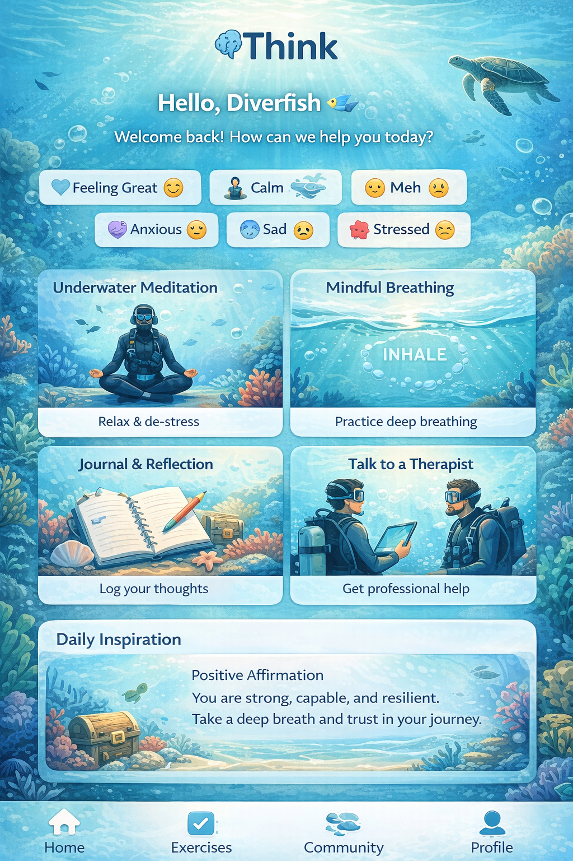

Prompt 3

You are a scuba diver. Create an image showing the interface of features available in your app about mental health and wellbeing called iThink. It is a serene, ocean themed app. It is for people to calm down and meditate to ocean sounds such as waves and whale noises catering to neurotic or overly anxious, hyper people.

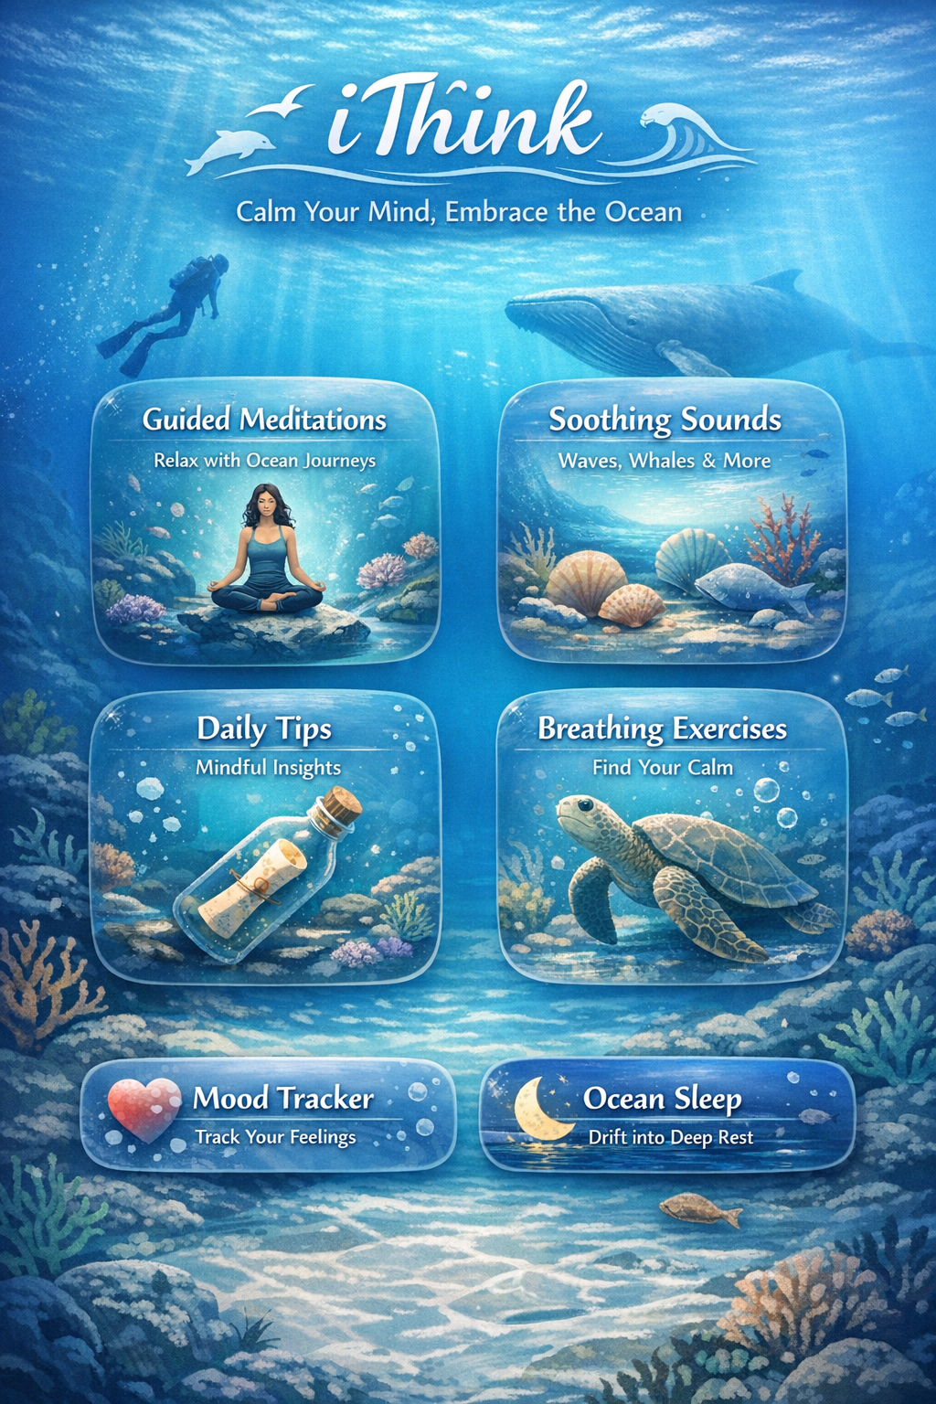

Prompt 4

You are a scuba diver. Create an image showing the interface of features available in your app about mental health and wellbeing called iThink. It is a serene, ocean themed app. It is for people to calm down and meditate to ocean sounds such as waves and whale noises catering to neurotic or overly anxious, hyper people. Please avoid using human figures and over usage of bright colours. It should have a serene welcoming colour scheme with incorporation hues of blue.

